‌**T‌ECH‌**CAMP‌‌ **‌KENYA‌ ‌**

**‌*PYTHON‌ ‌PROGRAMMING‌ ‌BASICS‌ ‌TASK‌***

Attempt the task below. *NB: Do not struggle with syntax, refer to online resources.*

**SECTION A**

**TASK 1:**

Write a program which accepts a string as input to print "Yes" if the string is "yes", "YES" or "Yes", otherwise print "No".

*Hint: Use input () to get the persons input*

**TASK 2:** Write a program that takes a list of numbers (for example, a = [5, 10, 15, 20, 25]) and makes a new list of only the first and last elements of the given list. For practice, write this code inside a function

**TASK 3:**

Ask the user for a number. Depending on whether the number is even or odd, print out an appropriate message to the user. *Hint: how does an even / odd number react differently when divided by 2?*

Extras:

1. If the number is a multiple of 4, print out a different message.

**TASK 4:**

With a given tuple (1, 2, 3, 4, 5, 6, 7, 8, 9, 10), write a program to print the first half values in one line and the last half values in one line.

**TASK 5:**

Write a program that takes the base and height of a triangle and returns its area.

**TASK 6:**

Given an integer **n(**use the input() function) perform the following conditional actions:

* If**n** is odd, print Weird
* If **n** is even and in the inclusive range of 2  to 5 , print Not Weird
* If **n** is even and in the inclusive range of 6 to 20, print Weird
* If **n** is even and greater than 20, print Not Weird

**SECTION B**

***Task 1***

Given the participants' score sheet for your University Sports Day, you are required to find the runner-up score. You are given scores. Store them in a list and find the score of the runner-up.

Input Format

The first line contains **n**. The second line contains a list **x** of **i** integers each separated by a space.

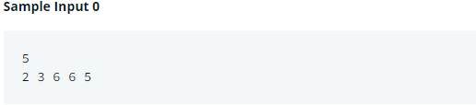

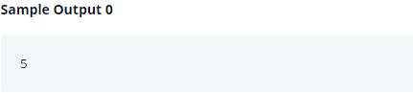

**Task 2**

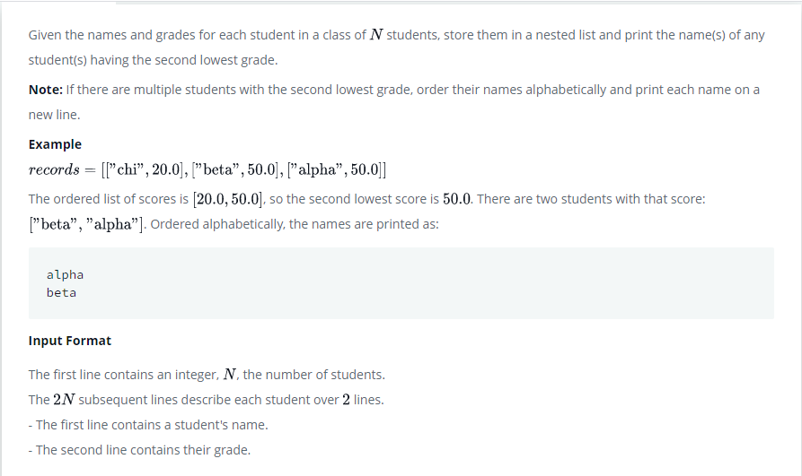

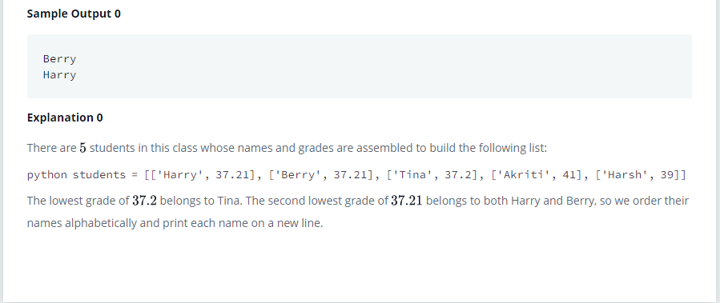

**TASK 3**



